1. Which plant generation is diploid?
*a. sporophyte
b. gametophyte

2. Which generation is haploid?
a. sporophyte
*b. gametophyte

3. Spores are
*a. haploid
b. diploid
c. partly haploid and partly diploid

4. Gametes are
*a. haploid
b. diploid
c. partly haploid and partly diploid

5. Lycopods have vascular tissue.
*a. true
b. false

6. How do lycopods disperse to new habitats?
a. By swimming
*b. By spores
c. By seeds

7. Lycopod spores are formed by
a. mitosis
*b. meiosis
c. both mitosis and meiosis

8. On the lycopod below, the structure labeled “a” is the
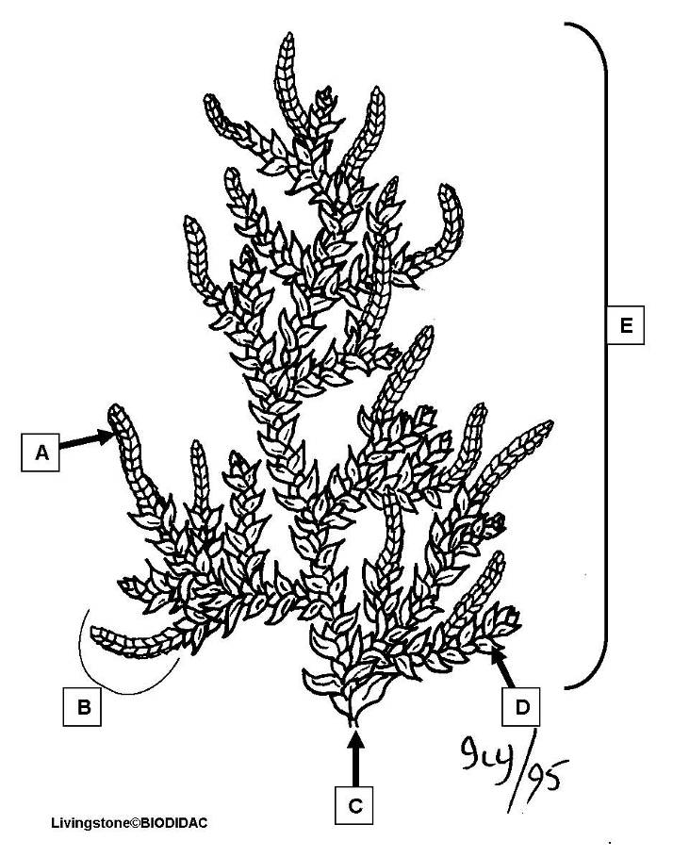

*a. sporophyll
b. sporophyte
c. stem
d. strobilus
e. vegetative leaf

9. On the lycopod below, the structure labeled “b” is the

a. sporophyll
b. sporophyte
c. stem
*d. strobilus
e. vegetative leaf

10. On the lycopod below, the structure labeled “c” is the

a. sporophyll
b. sporophyte
*c. stem
d. strobilus
e. vegetative leaf

11. On the lycopod below, the structure labeled “d” is the

a. sporophyll
b. sporophyte
c. stem
d. strobilus
*e. vegetative leaf

12. On the lycopod below, the structure labeled “e” is the

a. sporophyll
*b. sporophyte
c. stem
d. strobilus
e. vegetative leaf

13. On the lycopod strobilus diagram below, the structure labeled “a” is the
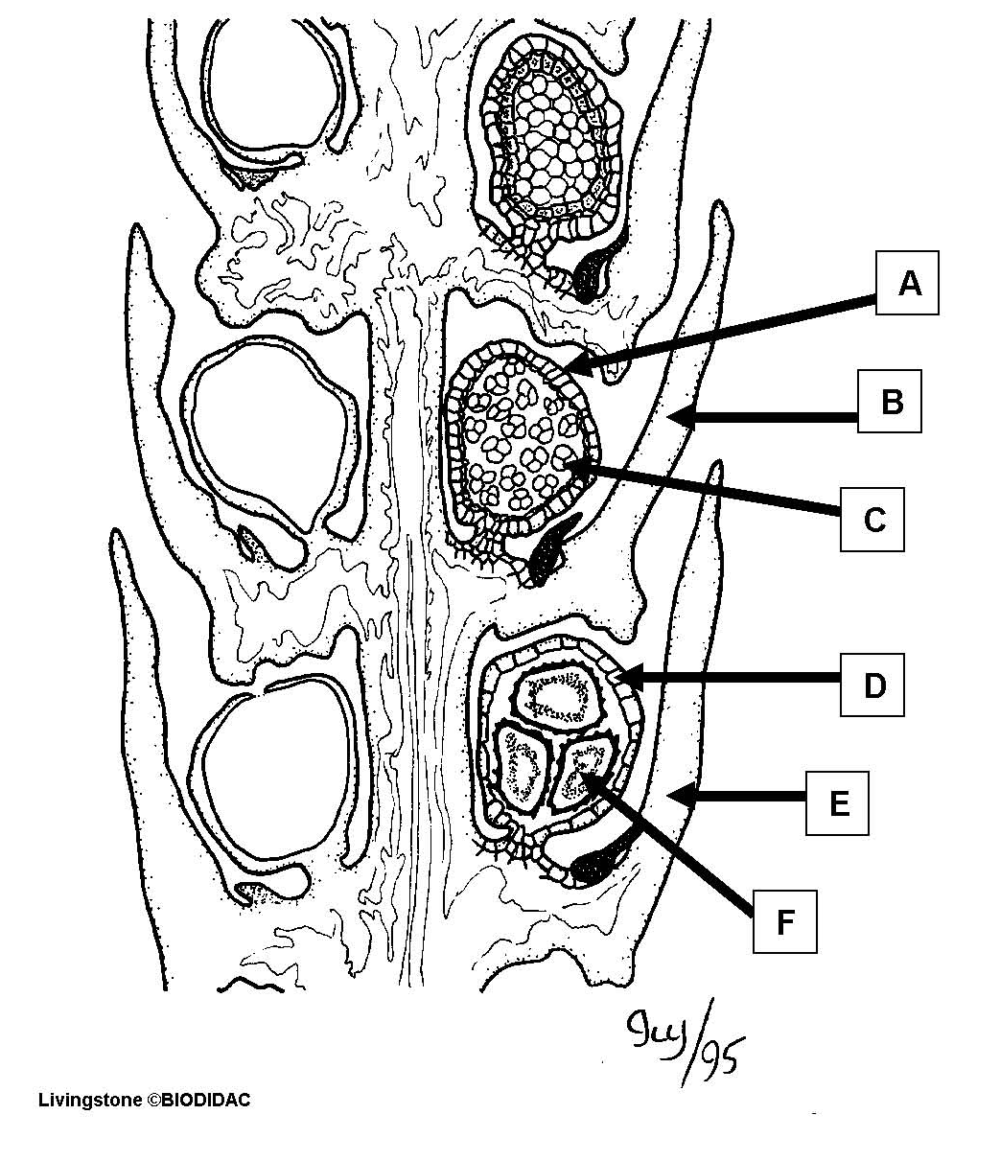

a. megasporangium
b. megaspore
c. megasporophyll
*d. microsporangium
e. microspore
f. microsporophyll

14. On the lycopod strobilus diagram below, the structure labeled “b” is the

a. megasporangium
b. megaspore
c. megasporophyll
d. microsporangium
e. microspore
*f. microsporophyll

15. On the lycopod strobilus diagram below, the structure labeled “c” is the

a. megasporangium
b. megaspore
c. megasporophyll
d. microsporangium
*e. microspore
f. microsporophyll

16. On the lycopod strobilus diagram below, the structure labeled “d” is the

*a. megasporangium
b. megaspore
c. megasporophyll
d. microsporangium
e. microspore
f. microsporophyll

17. On the lycopod strobilus diagram below, the structure labeled “e” is the

a. megasporangium
b. megaspore
*c. megasporophyll
d. microsporangium
e. microspore
f. microsporophyll

18. On the lycopod strobilus diagram below, the structure labeled “f” is the

a. megasporangium
*b. megaspore
c. megasporophyll
d. microsporangium
e. microspore
f. microsporophyll

